COLLEGE NAME : DONBOSCOCLEGE (CO-ED), YELAGIRI HLLS

COLLEGE CODE : 358

DEPARTMENT : DEPARTMENT OF COMPUTER APPLICATIONS

TITLE : CRICKET PLAYER PERFORMANCE TRACKING APPLICATION: CRICKSTATS

TEAM MEMBERS NAME :

S.NO | NAME | REGISTER NUMBER
1 | ANTONY AJAI | 35823U09009
2 | ANTONY AROCKIA DINESH A | 35823U09010
3 | ANTONY DOSS | 35823U09011
4 | ANTONY SALAMON | 35823U09012
5 | ARUL JEROME | 35823U09014

ABSTRACT
Cricket Player Performance Tracking Application: CRICKSTATS
Cricket is a performance-oriented sport where accurate statistics and detailed analysis play a crucial role in team success and player development. However, many school, college, and local-level cricket teams still rely on manual methods such as paper records or spreadsheets to manage player performance data. These traditional systems often result in data inconsistency, calculation errors, lack of structured relationships, and difficulty in generating analytical reports.
The Cricket Player Performance Tracking Application – CRICKSTATS is a cloud-based solution developed using Salesforce to address these challenges. The system is designed to capture, store, and analyze match-by-match performance data of cricket players in a centralized and structured manner. It utilizes custom objects such as Player and Match Performance, along with Master-Detail and Lookup relationships, to ensure data integrity and efficient data management.
The application enables automatic calculation of key performance metrics including total runs, wickets, strike rate, and economy rate through roll-up summary fields and formula fields. It also provides dynamic reports and interactive dashboards that help coaches and team managers evaluate player consistency, compare performances, and make informed team selection decisions.
By transforming manual record-keeping into a secure, automated, and analytics-driven system, CRICKSTATS enhances transparency, improves operational efficiency, and promotes data-driven strategic planning. The project demonstrates how modern CRM technology can be effectively applied in the field of sports analytics to improve performance management and long-term player development.

PROBLEM STATEMENT
In many cricket teams, especially at school, college, and local club levels, player performance records are still maintained manually using notebooks, paper records, or basic spreadsheets. While this method may work for a small number of matches, it becomes highly inefficient as the number of players and matches increases. Manual systems lack automation and structured data management, which creates several operational challenges.
Some of the major problems faced in traditional systems include:
- Data duplication and inconsistency
- Manual calculation errors in averages and strike rates
- Difficulty in tracking match-by-match performance
- No centralized database for storing player statistics
- Time-consuming report generation
- Limited analytical and comparison capabilities
Because of these limitations, coaches and team managers find it difficult to evaluate player performance accurately. Important metrics such as total runs, wickets taken, economy rate, and batting average require manual calculations, which increases the chances of mistakes. Moreover, comparing players across multiple matches becomes complicated due to the absence of structured relationships between player data and match data.
Another significant issue is the lack of real-time insights. In competitive cricket, decision-making must be quick and data-driven. However, without automated reports and dashboards, team selection and strategy planning are often based on assumptions rather than factual performance data. This leads to:
- Subjective player selection
- Delayed strategic planning
- Inaccurate performance analysis
- Reduced transparency in evaluation
Additionally, traditional systems do not provide proper validation rules, security controls, or role-based access. This may result in unauthorized changes, data loss, or incomplete records. Over time, maintaining historical data for long-term performance tracking becomes increasingly complex.
Therefore, there is a strong need for a centralized, automated, and cloud-based Cricket Player Performance Tracking Application like CRICKSTATS, developed using Salesforce. Such a system can ensure accurate data storage, structured relationships between objects, automated calculations, secure access, and powerful reporting capabilities. Implementing this solution will significantly improve performance evaluation, strategic decision-making, and overall team management efficiency.

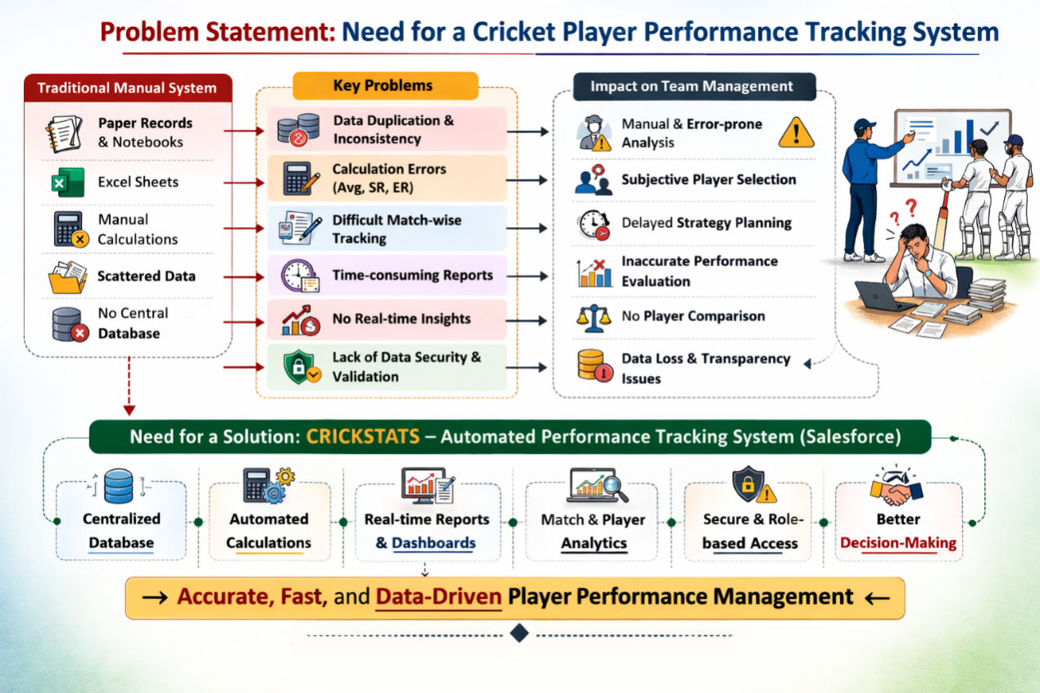

PROPOSED SOLUTION
To overcome the identified challenges, the proposed solution is the development of CRICKSTATS, a cloud-based Cricket Player Performance Tracking Application developed using Salesforce. The application is designed to provide a structured, scalable, and analytics-driven environment for managing cricket performance data.

Player Object
This object stores personal and career-related details of players such as:
- Player Name
- Age
- Role (Batsman, Bowler, All-Rounder, Wicketkeeper)
- Batting Style
- Bowling Style
- Matches Played
- Total Runs
- Total Wickets
- Batting Average

Match Performance Object
This object captures detailed performance data for each match played by a player:
- Match ID
- Match Date
- Opponent Team
- Runs Scored
- Balls Faced
- Wickets Taken
- Overs Bowled
- Catches
- Strike Rate
- Economy Rate
A Master-Detail relationship is established between Player (Master) and Match Performance (Detail). This ensures strong data integrity and allows the use of Roll-Up Summary Fields to automatically calculate totals and averages. If a Player record is deleted, all related match records are automatically removed, maintaining consistency.
Additionally, Lookup relationships can be used to connect:
- Player to Team
- Match Performance to Tournament
The solution also incorporates:
- Validation Rules to ensure accurate data entry
- Custom Reports for performance comparison
- Interactive Dashboards for visual insights
- Role-based access control for security
The application leverages Salesforce’s reporting engine to generate real-time insights such as top scorers, leading wicket-takers, and player consistency charts.
Thus, CRICKSTATS transforms manual record-keeping into a structured, automated, and intelligent sports analytics system.
WORK FLOW DIAGRAM
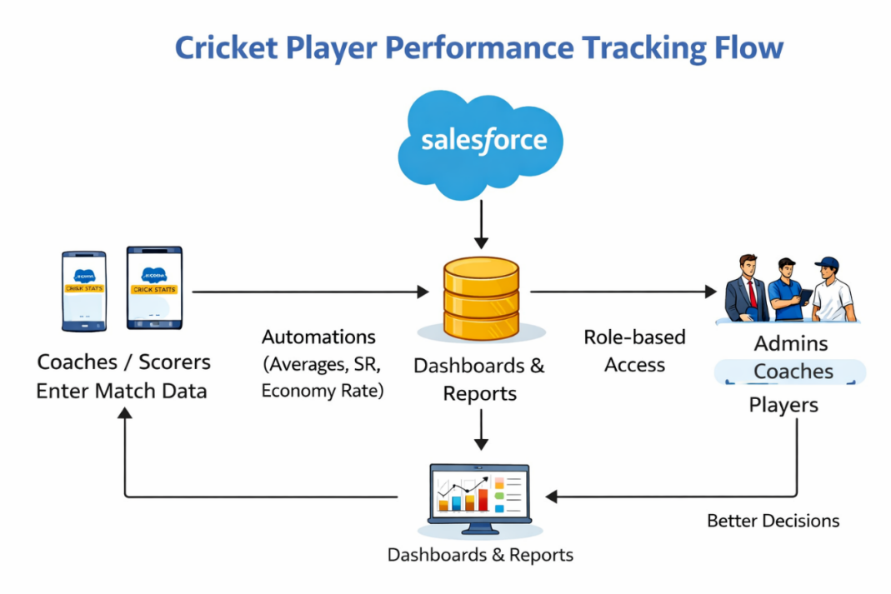

SUMMARY

CRICKSTATS is a comprehensive cricket performance management system built on Salesforce to streamline the tracking, analysis, and management of player statistics. The system centralizes all cricket-related performance data into structured custom objects, enabling efficient storage and retrieval of information.
The application uses a Master-Detail relationship between Player and Match Performance to maintain strong referential integrity and enable automatic aggregation of performance metrics. Roll-up summary fields calculate totals such as runs scored and wickets taken without manual computation.
Through customized reports and dashboards, users can visualize data trends and compare player performances across matches and tournaments. This improves transparency and promotes fair selection processes. The cloud-based nature of Salesforce ensures that data is accessible from anywhere, while maintaining security and scalability.
CRICKSTATS not only simplifies performance tracking but also enhances analytical capabilities. Coaches and team managers can evaluate player strengths, weaknesses, and improvement areas through structured insights. The system reduces manual workload, minimizes errors, and improves operational efficiency.
Overall, the application demonstrates how CRM technology can be extended beyond business environments into the field of sports analytics. It bridges the gap between raw data collection and strategic sports management, making performance evaluation more objective and reliable.

SCREEN SHORTS
HOME PAGE:

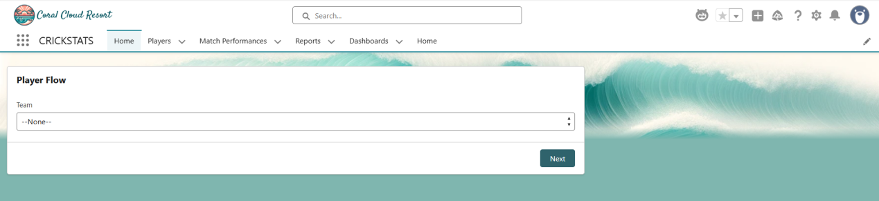

PLAYER DETAILS :

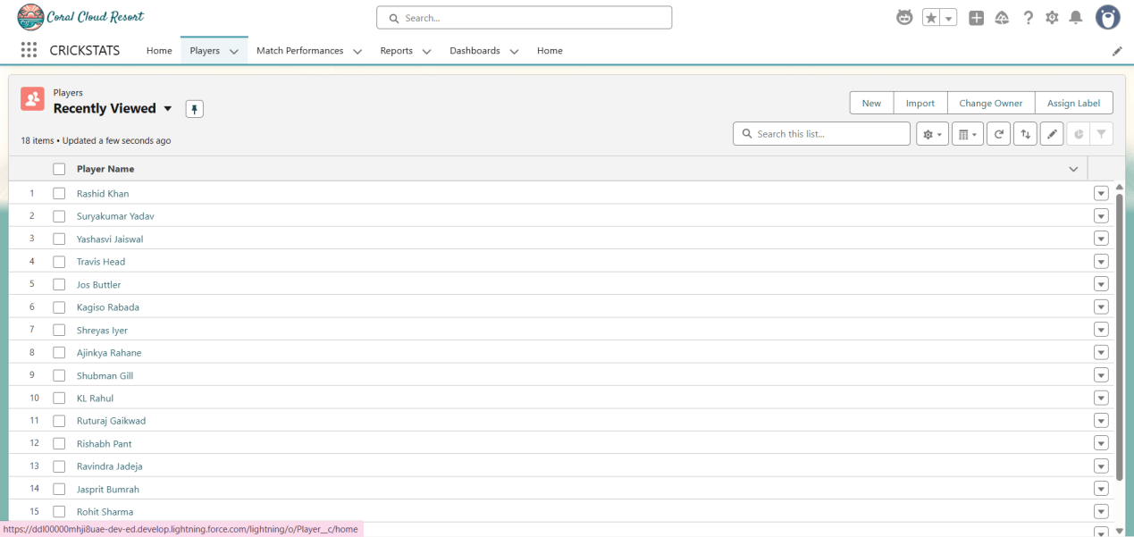

PLAYER FLOW:

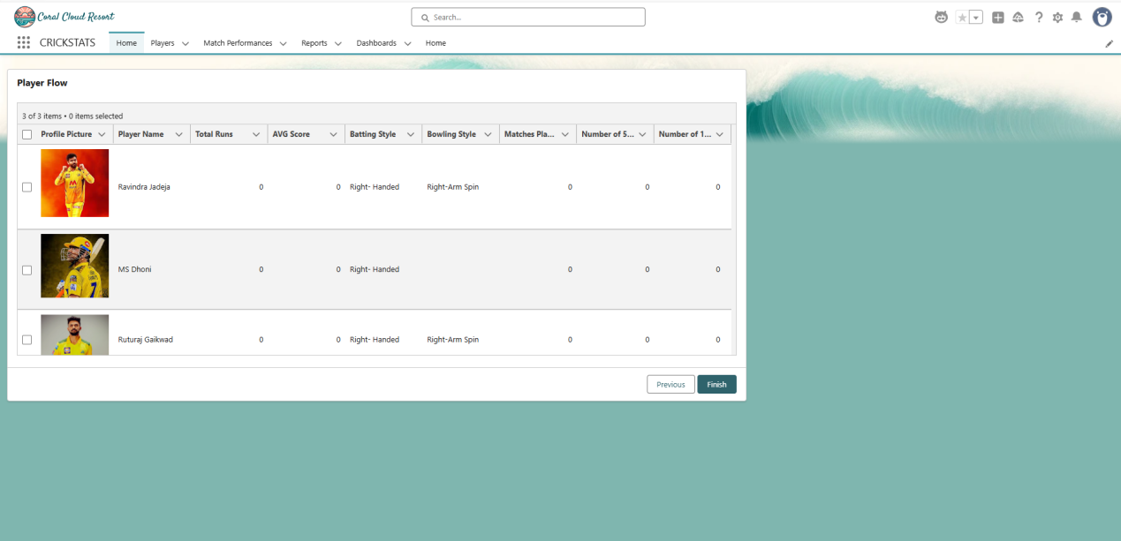

MATCH PERFORMANC PAGE :

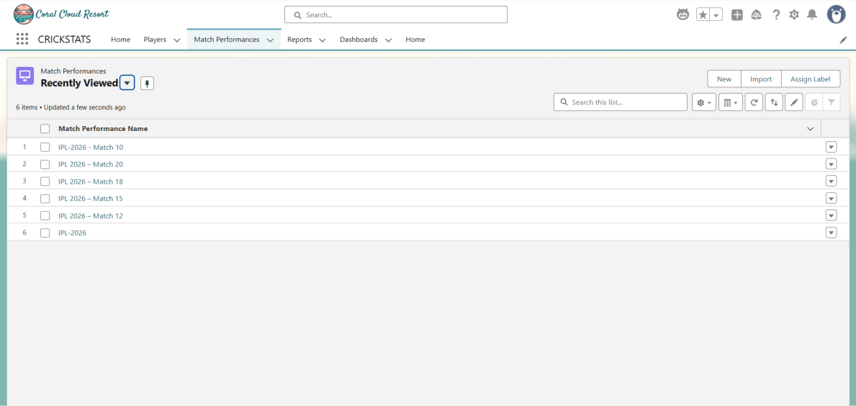

INDIVIDUAL MATCH PERFORMANCE :

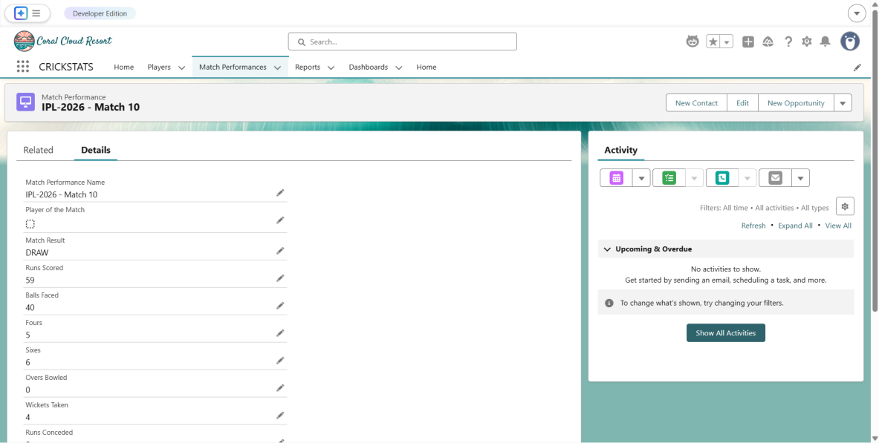

REPORTS PAGE :

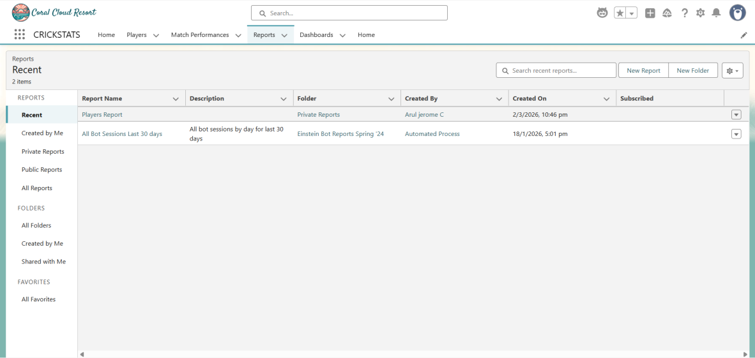

PLAYER REPORTS:

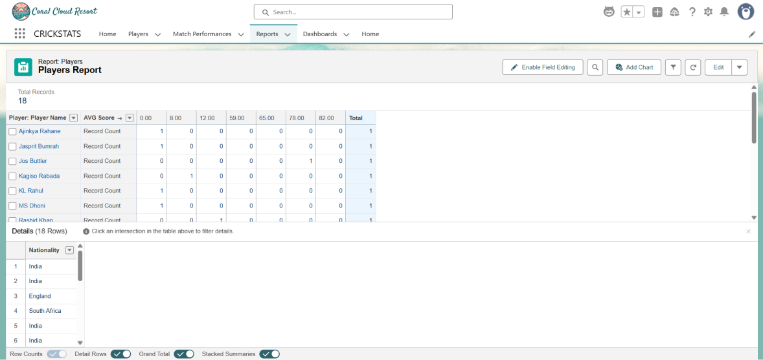

INDIVIDUAL PLAYER RECORD :

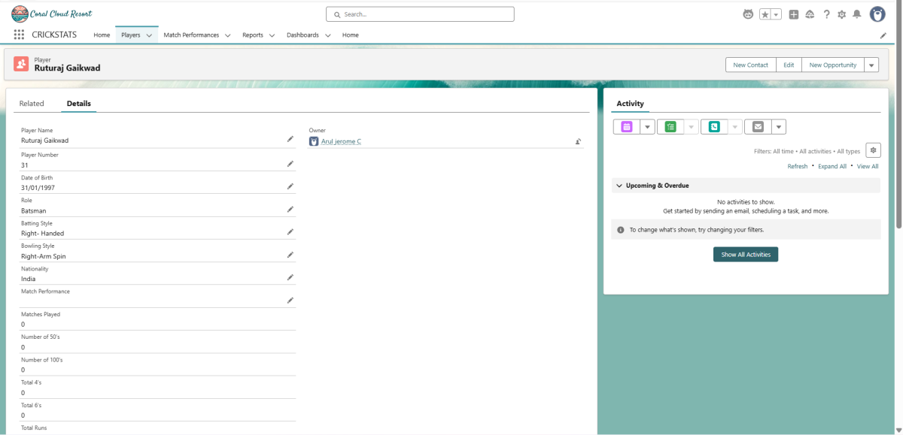

DASHBOARD PAGE :

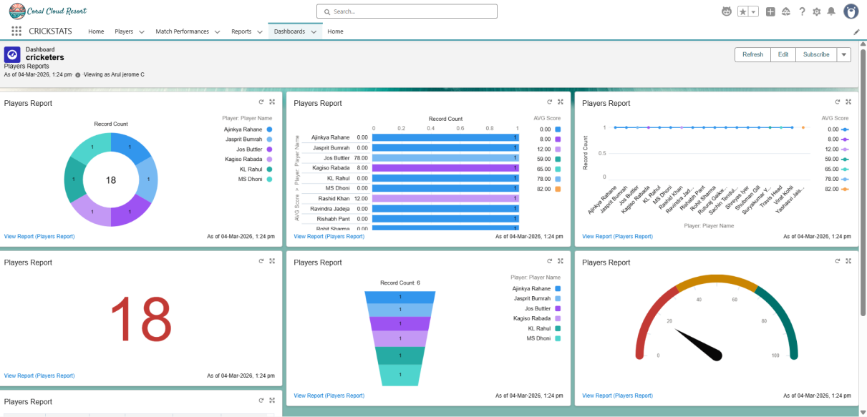

CONCLUSION

The Cricket Player Performance Tracking Application – CRICKSTATS successfully addresses the limitations of traditional performance management systems used in cricket teams. By implementing the solution on Salesforce, the project ensures data accuracy, automation, security, and scalability.
The system provides a structured method of capturing detailed match-by-match performance data and linking it effectively to individual player records. Automated calculations eliminate manual errors and save time. The use of reports and dashboards empowers decision-makers with real-time insights, improving team selection and strategic planning.
CRICKSTATS enhances transparency in player evaluation and promotes data-driven decisions. It reduces dependency on subjective judgments and ensures fairness in performance assessment. The secure cloud infrastructure guarantees safe storage and controlled access to sensitive data.
In conclusion, this project demonstrates how modern cloud-based CRM platforms like Salesforce can be effectively utilized in sports domains. CRICKSTATS not only improves operational efficiency but also contributes to long-term player development and competitive team performance.
The successful implementation of this system highlights the importance of integrating technology with sports analytics, paving the way for smarter and more strategic cricket management in the future.

